## Steps to execute PS script for Application Configuration

#### **KMS Server**

**Table of Contents**

Initial Steps 1

Prerequisites 1

Steps to perform unit testing 2

KMS Script Details 6

#### Initial steps :

* User must have access to AWS account.

#### Prerequisites: (we are installing it through powershell scripts)

**Following software should be installed:**

1. Redistributable
2. Native client
3. Mysqlodbc(32-bit)
4. AWS CLI
5. Cloudwatch

**Steps to perform:**

Step1. Search EC2 & click on EC2 and then click on launch instance

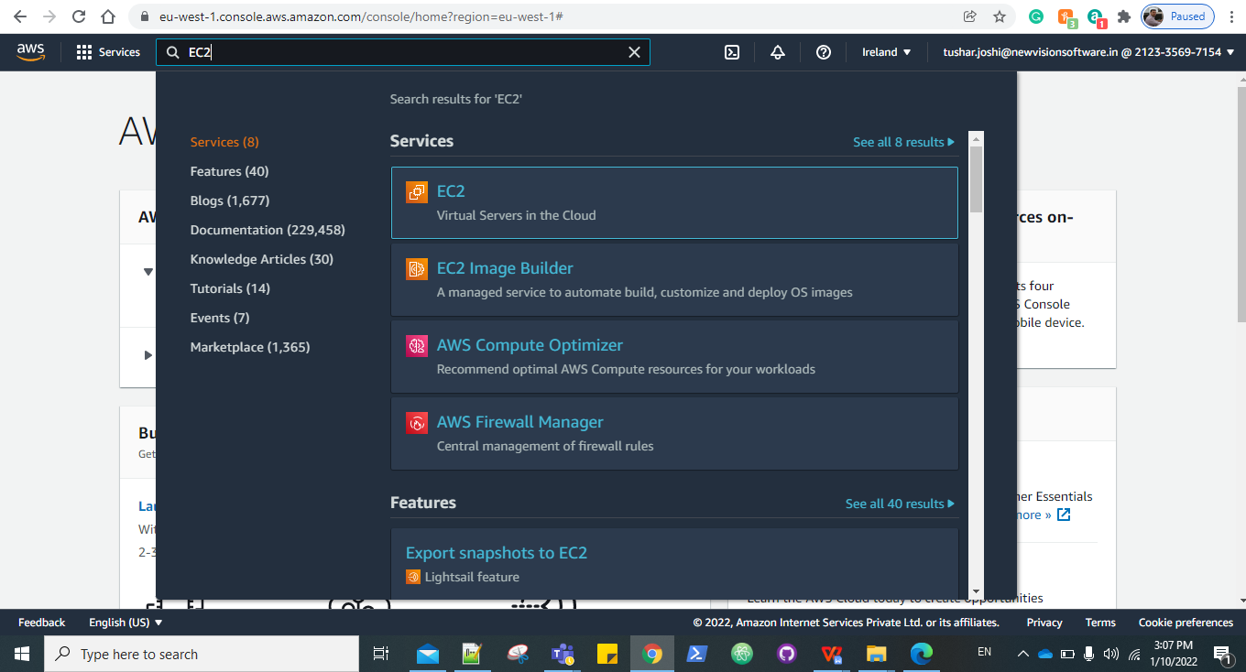

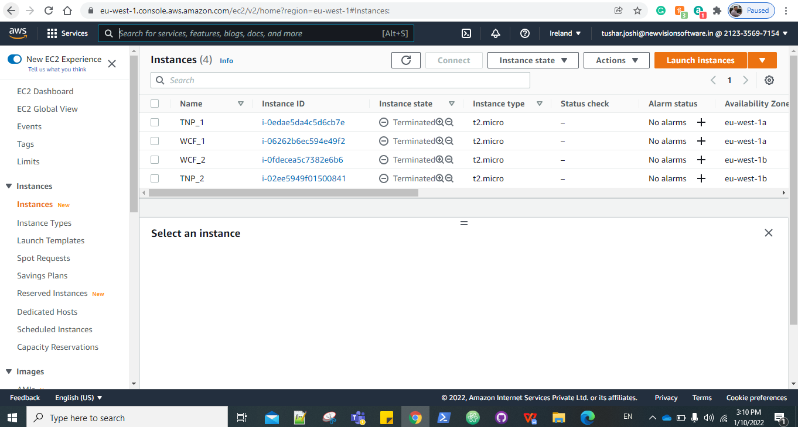

Step2. Choose Amazon machine image

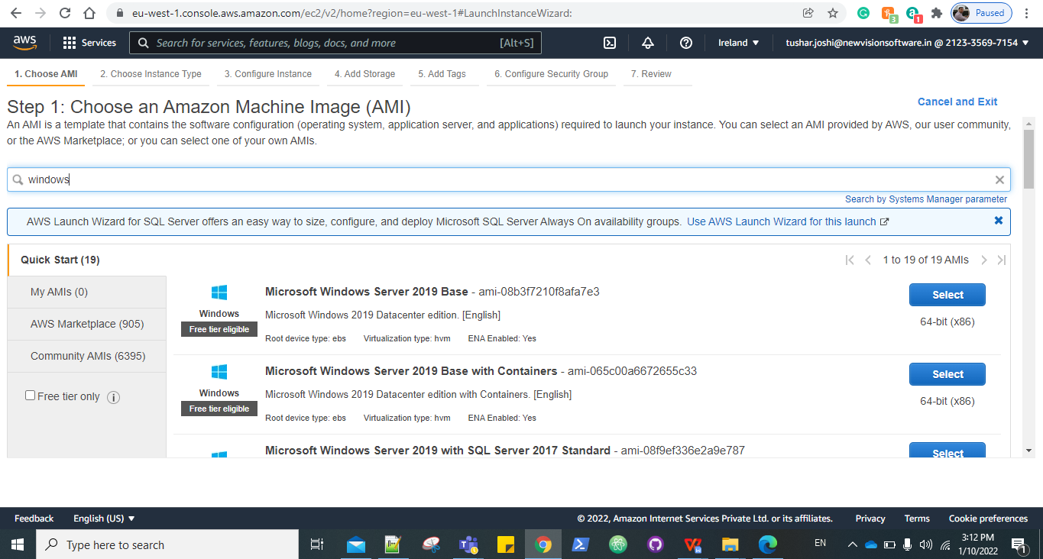

Step 3: Choose an Instance Type.

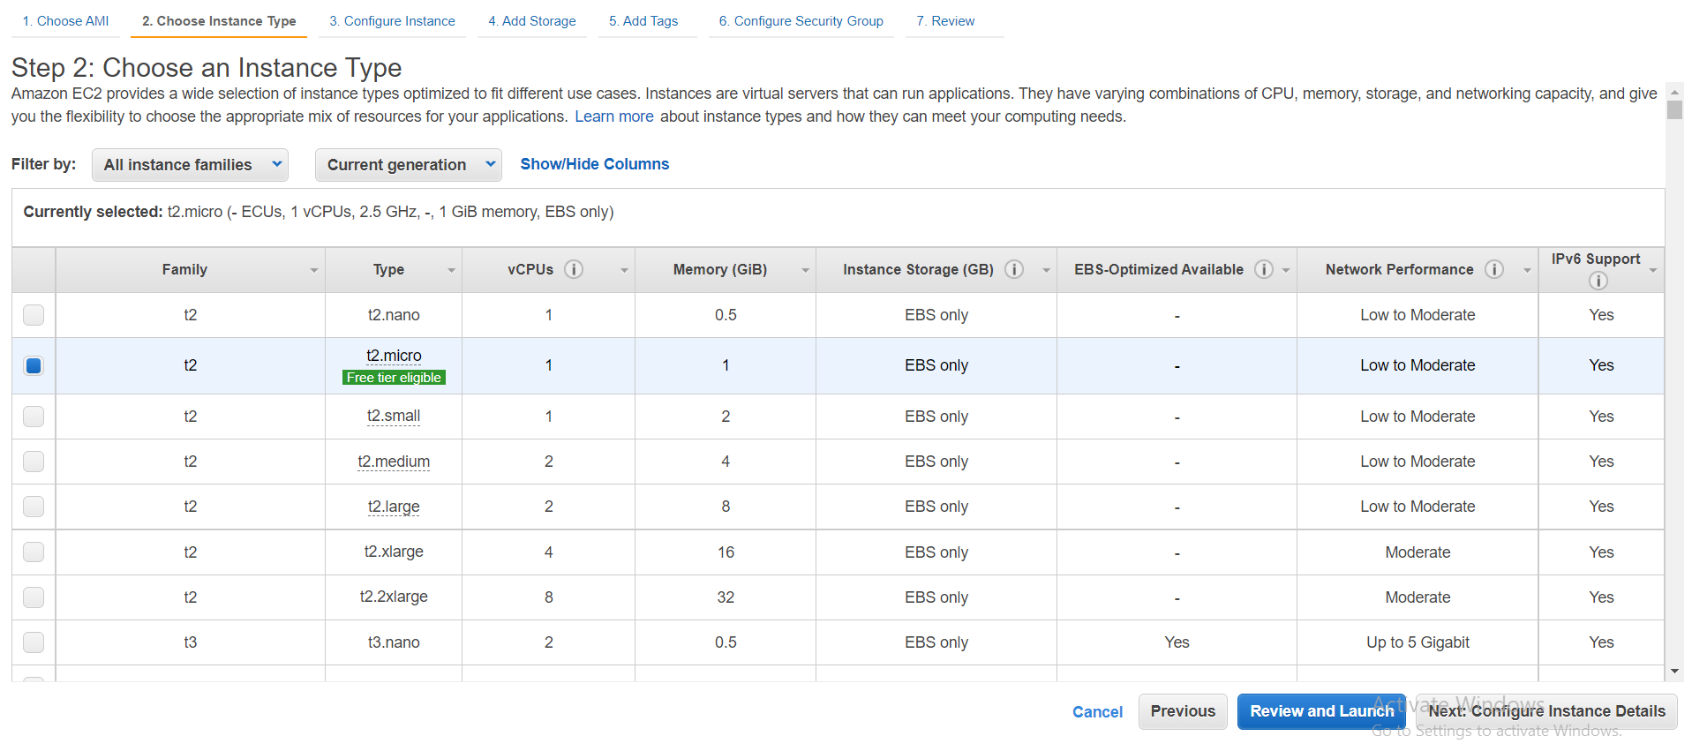

Step 4: select network and subnet.

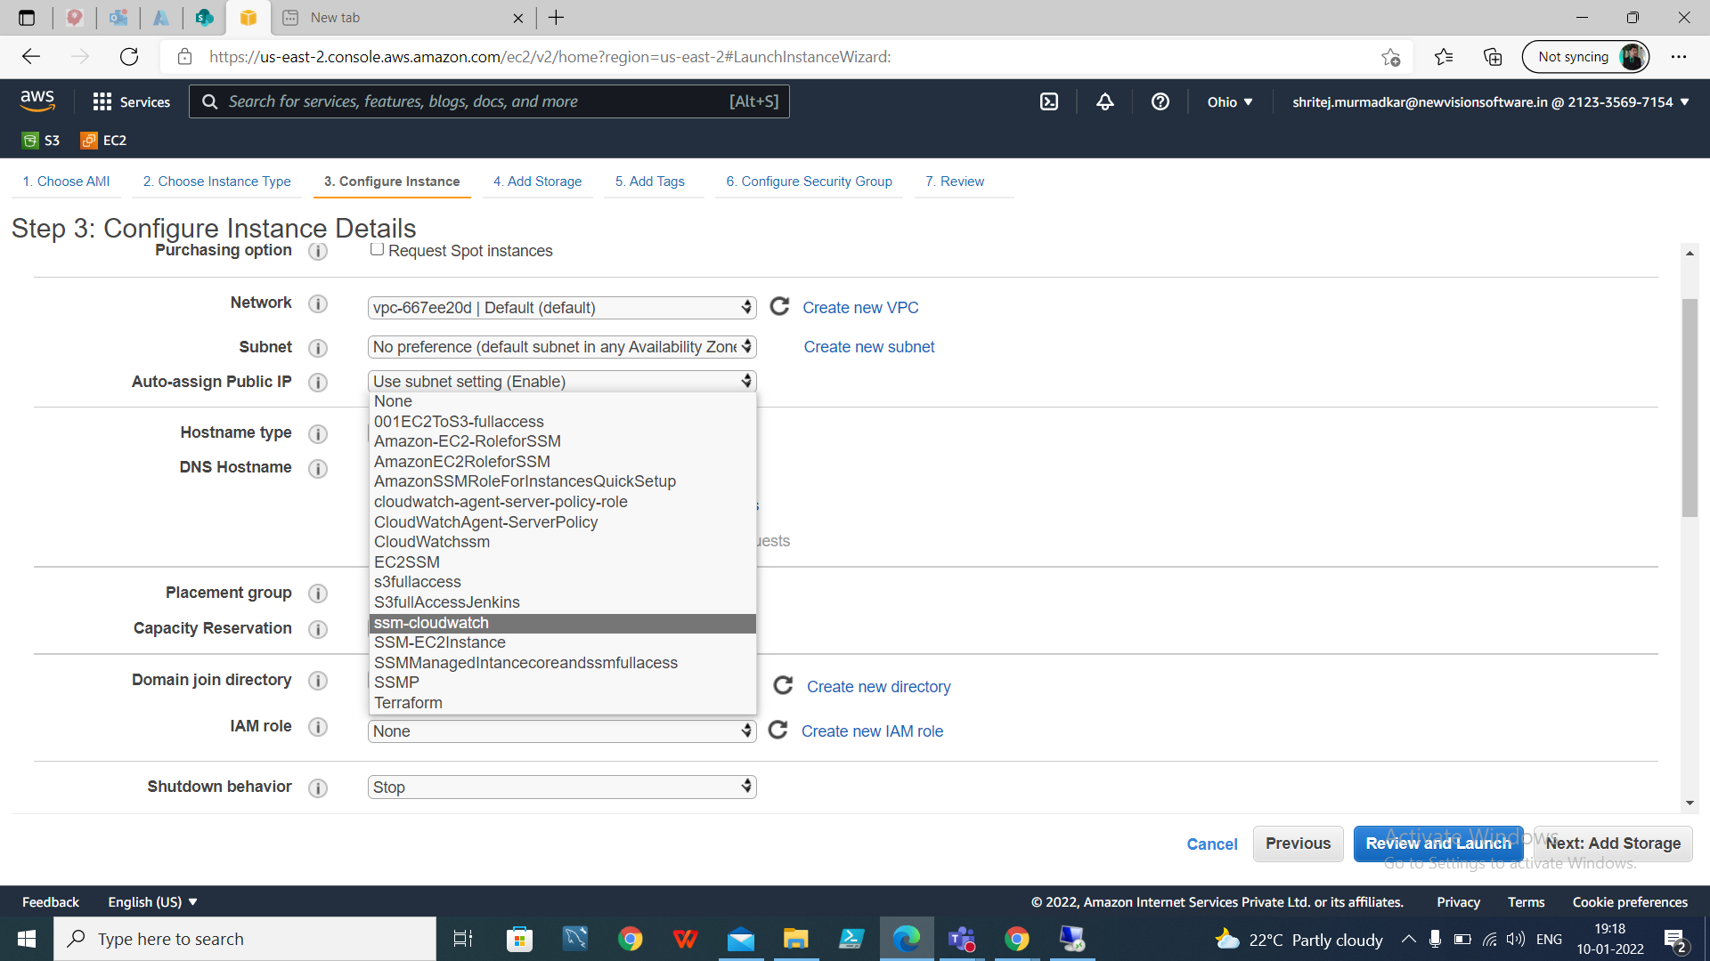

Step 5: Add storage.

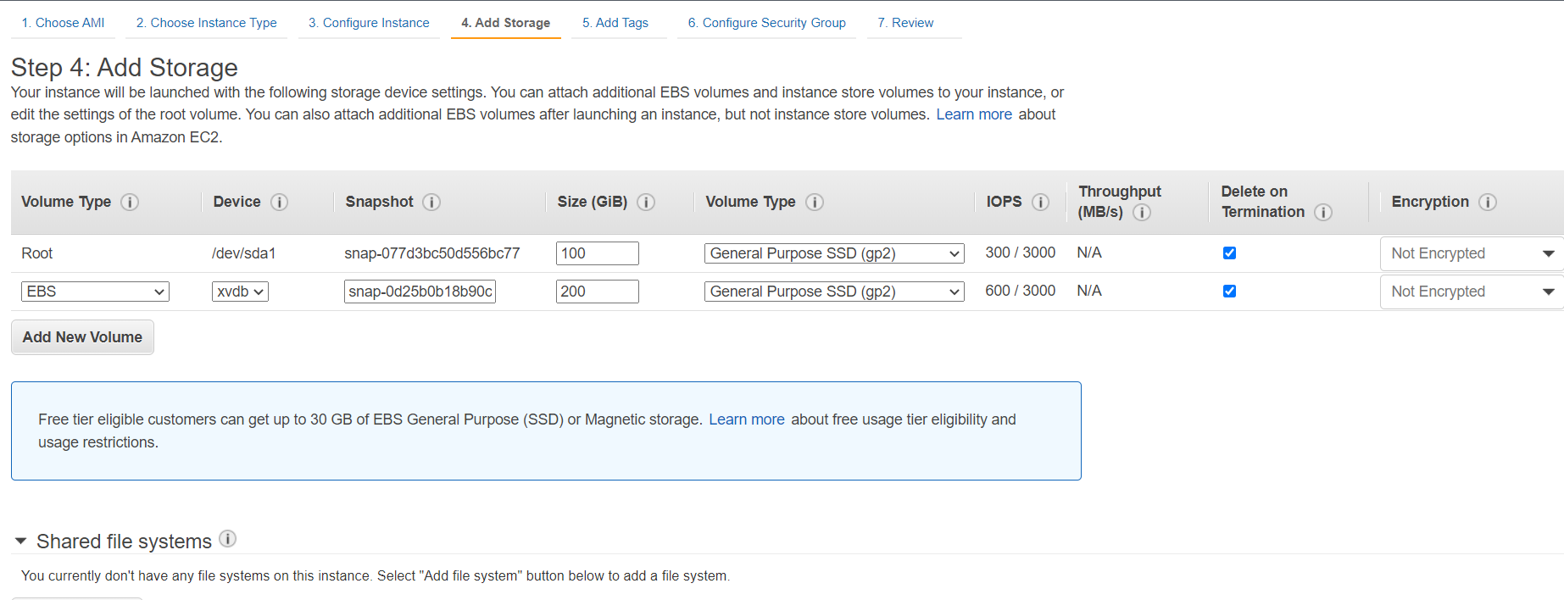

Step 6: Give the Tags if needed.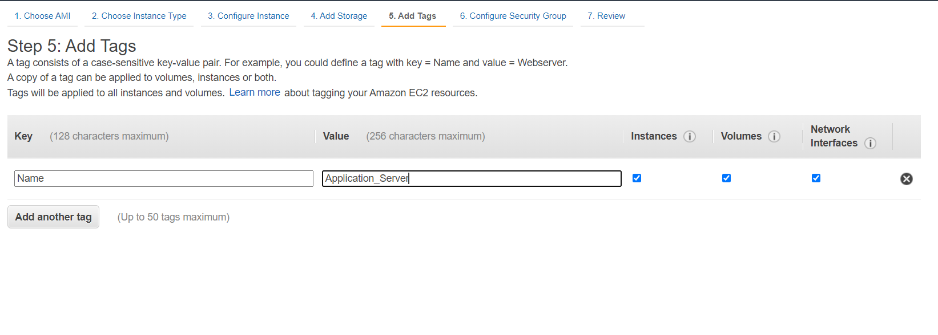

Step 7: Select the security group.

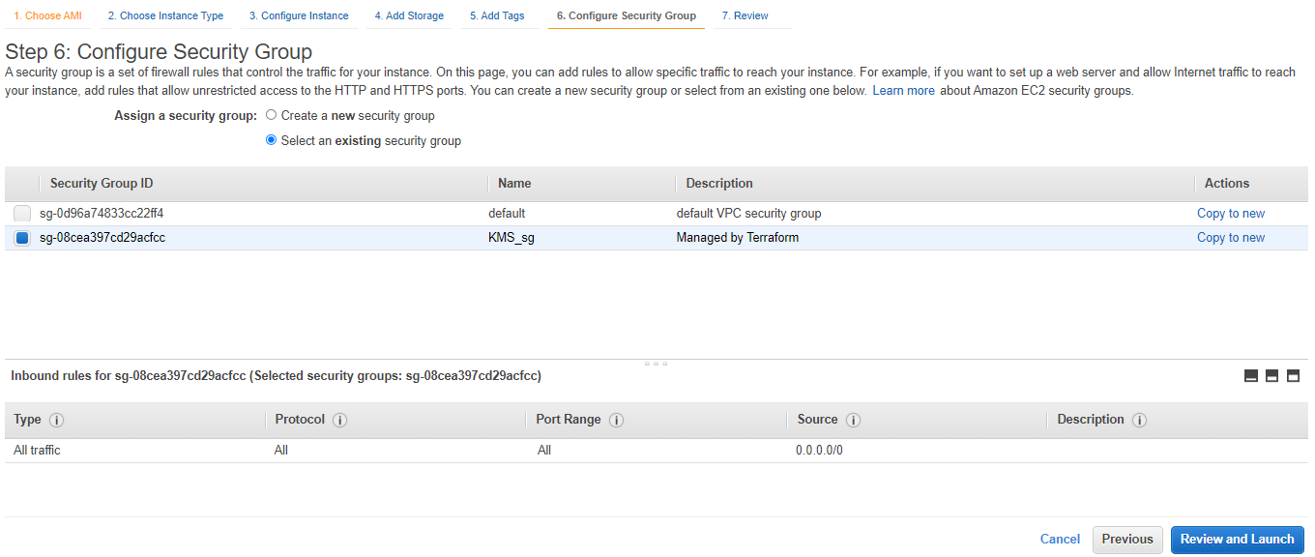

Step 8: Review and launch, Select the existing key pair or create new and launch.

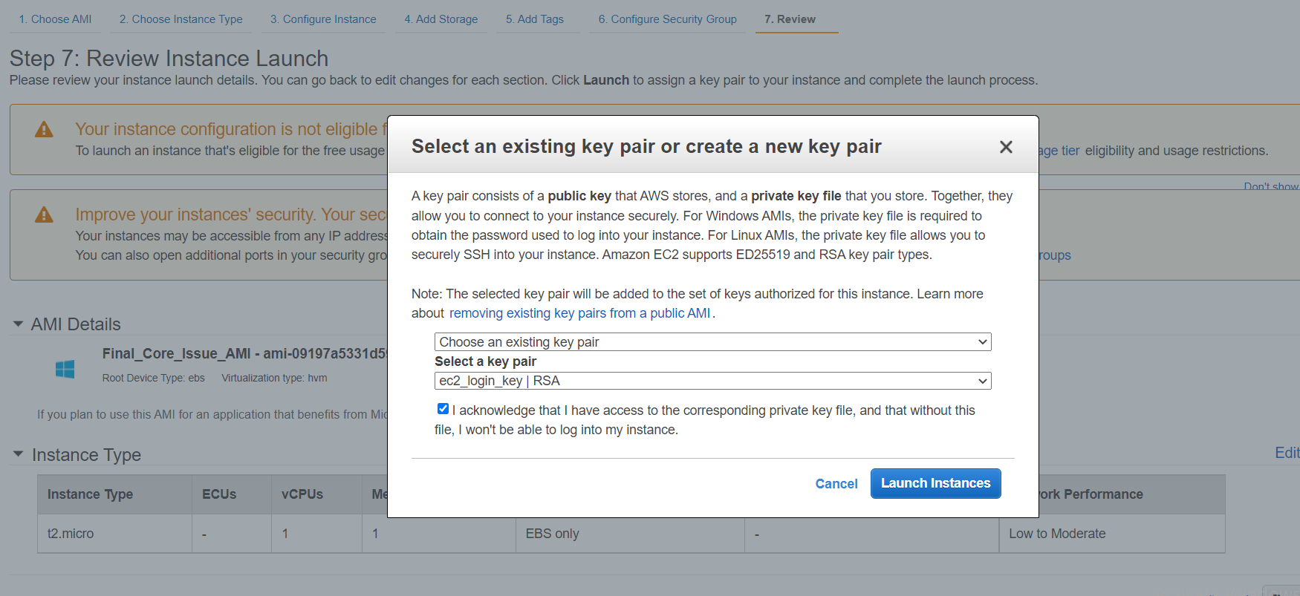

#### **KMS Server Script Details:**

1. **Final_var_master:** This is var master script used to execute all power shell scripts to configure KMS server.
2. **Logonservice:** This will grant a user to local policy.
3. **Folderperm:** This will allow full permission to the KMS folder
4. **Firewall:** This will create inbound rule for 1111 and 9999.
5. **KMS_config:** This script file is used to import variables for each object of KMS_DB_name, KMS_DB_host, KMS_svc_name from path “C:\testvariable.xml “ and it will define the variables in lookuptable array.
6. **KMS_exe:** This script file is used to import variables for each object of KMS_DB_name, KMS_DB_host, KMS_svc_name from path “C:\testvariable.xml “ and it will define the variables in lookuptable array.

Also it will check if the contents like $_.Key matching with $original_file.If it's matches then it will define the source path in $destination_file for those contents.

1. **newKMScrevar:** This script file will take the value KMS username and password from the variable file C:\testvariable.xml and then it will start the KMS server.
2. **ODBC_Configuration:** This script is used to setup ODBC Driver 17 for SQL Server
3. **Run_KMS:** This script is used to install KMS services
4. **Start_service:** This script is used to start the KMS service
5. **install_prerequisites:** This script is used to install the vcrediste_x86 and other sqlnc
6. **URLInternetExp:** This script is used to open webrequest for url <http://localhost:8081/index.sshtml> through different browsers
7. **testvariable**: In this xml file contains all the variables for all the servers, In this file the tag name will fetch all the variables for that specific environment Eg. <ENV>DEV</ENV>

It will consist all environment tag which will include all server tags.